**Aim:** To recommend an item to the user using collaborative-based filtering approach

**IDE:** Google Colab

# Theory:

There are a lot of applications where websites collect data from their users and use that data to predict the likes and dislikes of their users. This allows them to recommend the content that they like. Recommender systems are a way of suggesting or similar items and ideas to a user’s specific way of thinking.

Recommender System is different types:

* **Collaborative Filtering:** Collaborative Filtering recommends items based on similarity measures between users and/or items. The basic assumption behind the algorithm is that users with similar interests have common preferences.
* **Content-Based Recommendation:** It is supervised machine learning used to induce a classifier to discriminate between interesting and uninteresting items for the user.

In Collaborative Filtering, we tend to find similar users and recommend what similar users like. In this type of recommendation system, we don’t use the features of the item to recommend it, rather we classify the users into clusters of similar types and recommend each user according to the preference of its cluster.

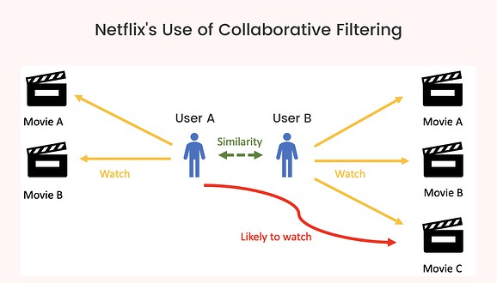

# Pre Lab Exercise:

1. When can you use collaborative-based recommendation system approach?
2. Write advantages of collaborative -based filtering approach
3. Write disadvantages of collaborative -based filtering approach

# Program (Code):

To be attached with

# Results:

To be attached with

# Observation:

**Post Lab Exercise:**

1. Are you satisfied with the results/ratings shown by your designed model? If yes, justify. If no, describe the probable reason for under performance of the system.
2. Recommend top-10 “movies” using MovieLens 100K dataset

(Link: <https://grouplens.org/datasets/movielens/100k/>). Attach the code with output. Also, write your observation for the same.